**STATIC CONFIGURATION USING 3 ROUTER**

**Steps to Configure and Setup clan configuration in Cisco Packet Tracer :**

**Step 1: First, open the cisco packet tracer desktop and select the devices.**

**Step2-Add 6pc , 3routerAND 3 SWITCHES .**

**Ste3-Add automatically wire to pc to switch and router.**

**Step4-Add there ip address**

|  |  |
| --- | --- |
| **•pc0** | **192.168.10.10/24** |
| **•pc1** | **192.168.10.11/24** |
| **•pc2** | **192.168.20.10/24** |
| **•pc3** | **192.168.20.11/24** |
| **•pc4** | **192.168.30.10/24** |
| **•pc5** | **192.168.30.11/24** |

|  |  |  |
| --- | --- | --- |
| **R1** | **R2** | **R3** |
| **c-192.168.10.0** | **c-112.1.1.0**  **c-113.1.1.0** | **c-113.1.1.0** |
| **c-112.1.1.0** | **c-192.168.20** | **c-192.168.30** |

**STEP 5 -Then click on pc and go to desktop and click on ip configuration and ip address.**

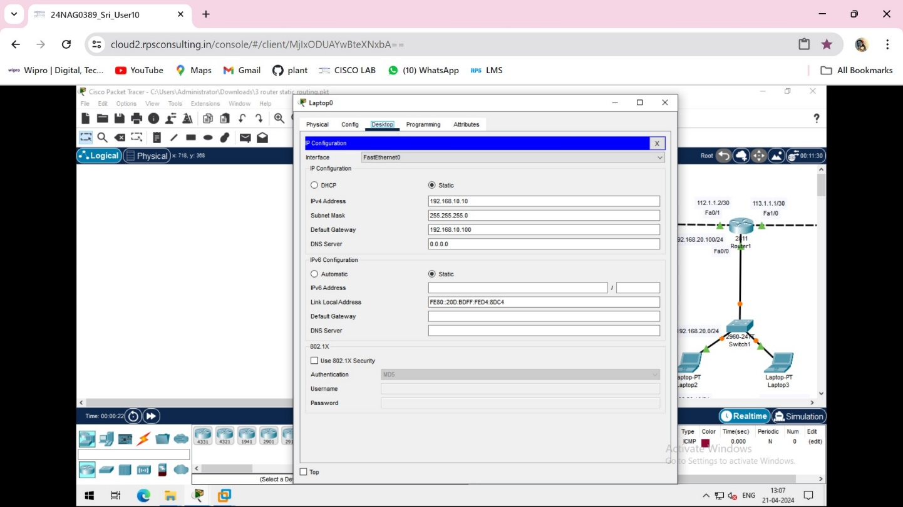

SSTEP 6- Then click on config the add default getways.

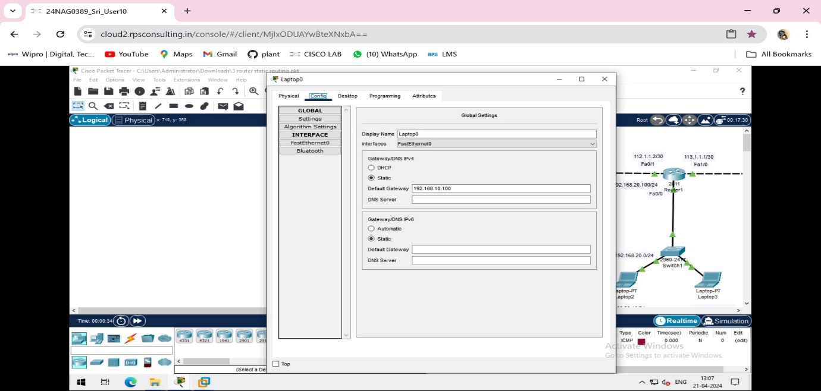

STEP 7 - Then go to router then go to physical address ad Ethernet port on NMSPETX.

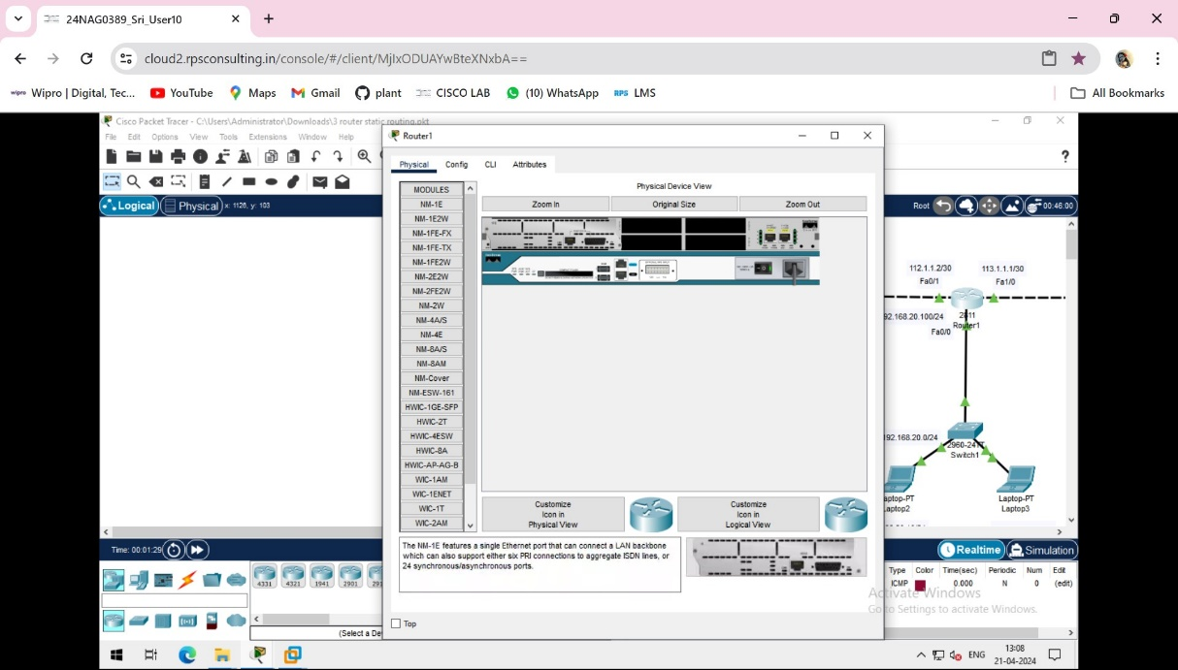

STEP 8- NOW ALL WIRES ARE CONNECTED MANUALLY

NOW GO TO ROUTERS AND CLICK ON CLI

Router R1 configuration:

Router>enable

Router#conf t

Router(config)#hostname R1

R1(config)#interface fastEthernet 0/0

R1(config-if)#ip address 192.168.10.100 255.255.255.0

R1(config-if)#no shutdown

R1(config-if)#exit

R1(config)#interface fastEthernet 0/1

R1(config-if)#ip address 112.1.1.1 255.255.255.252

R1(config-if)#no shut

R1(config-if)#^Z

R1#wr

Building configuration...

[OK]

Router R2 config:

Router>en

Router#conf t

Router(config)#hostname R2

R2(config)#interface fa0/1

R2(config-if)#ip add 112.1.1.2 255.255.255.252

R2(config-if)#no shut

R2(config-if)#exit

R2(config)#interface fa0/0

R2(config-if)#ip add 192.168.20.100 255.255.255.0

R2(config-if)#no shut

R2(config-if)#exit

R2(config)#int fa1/0

R2(config-if)#ip add 113.1.1.1 255.255.255.252

R2(config-if)#no shut

R2(config-if)#exit

R2(config)#^Z

R2#wr

Building configuration...

[OK]

R2#

%LINEPROTO-5-UPDOWN: Line protocol on Interface FastEthernet1/0, changed state to up

Router R3 config:

Router>en

Router#conf t

Router(config)#hostname R3

R3(config)#int fa0/1

R3(config-if)#ip add 113.1.1.2 255.255.255.252

R3(config-if)#no shut

R3(config-if)#exit

R3(config)#int fa0/0

R3(config-if)#ip add 192.168.30.100 255.255.255.0

R3(config-if)#no shut

R3(config-if)#^Z

R3#wr

Building configuration...

[OK]

R3#

To config static routing for Router R1:

R1#conf t

Enter configuration commands, one per line. End with CNTL/Z.

R1(config)#ip route 192.168.20.0 255.255.255.0 112.1.1.2

R1(config)#ip route 192.168.30.0 255.255.255.0 112.1.1.2

R1(config)#ip route 113.1.1.0 255.255.255.252 112.1.1.2

R1(config)#^Z

R1#

%SYS-5-CONFIG_I: Configured from console by console

R1#wr

Building configuration...

[OK]

R1#

To config static routing for Router R2:

R2#conf t

Enter configuration commands, one per line. End with CNTL/Z.

R2(config)#

R2(config)#ip route 192.168.10.0 255.255.255.0 112.1.1.1

R2(config)#ip route 192.168.30.0 255.255.255.0 113.1.1.2

R2(config)#^Z

R2#

%SYS-5-CONFIG_I: Configured from console by console

R2#wr

Building configuration...

[OK]

R2#

To config static routing for Router R3:

R3>

R3>en

R3#conf t

Enter configuration commands, one per line. End with CNTL/Z.

R3(config)#ip route 192.168.10.0 255.255.255.0 113.1.1.1

R3(config)#ip route 192.168.20.0 255.255.255.0 113.1.1.1

R3(config)#ip route 112.1.1.0 255.255.255.252 113.1.1.1

R3(config)#^Z

R3#

%SYS-5-CONFIG_I: Configured from console by console

R3#wr

Building configuration...

[OK]

R3#

NOW ALL PROCESS ARE DONE AND WHEN WE PING TO PC TO ANOTHER PC IT WILL SHOW SUCESSFULLY.AND STIMULATE IT